Eindhoven, 20.12.2024

Individual Project Final Results

**Student name: Kornelia Zarębińska**

**Student number: 5045916**

**Class: I2-CB-CMK**

Table of Contents

Introduction: 3

Research 3

Questions: 3

ICT methodology: 3

Design and development process: 4

Challenges and learnings 11

What I learned: 11

Challenges faced: 11

How I overcome challenges: 12

Conclusion 12

# Introduction:

I create this project to improve my infrastructure skills. I want to learn how to create segmented network using VMs and pfsense, and how to prevent against basic SQL Injection and brute attack.

Goal for this project is to modernize the café's operations by implementing a secure, and customer-friendly network infrastructure.

This project will let company to automate ordering process, reduce costs by needed less cashiers, and provide separate subnets for public and private use.

* Set up server with deployed web application
* Set up subnets for cashier and server
* Set up Wi-Fi subnet for public use
* Create a web application for ordering food and drinks

# Research

## Questions:

**How small company can securely designed and optimized network infrastructure to protect sensitive data ?**

* What role does network segmentation play in securing sensitive data?
* How can encryption techniques be applied to enhance data protection in small networks?
* What intrusion detection and prevention systems are most effective for small businesses?
* What strategies ensure ongoing monitoring and maintenance of a small company’s network security?

## ICT methodology:

* Workshop Methods, centered around the creation and development of ICT solutions. In my project: prototyping design of website, sketching network diagram.
* Lab Methods, include testing and analyzing solutions in controlled environments. In my project: testing for sql injection or making brute attack.
* Library Methods, involve gathering existing knowledge to boost research. In my project: create research document about VLANs.

# Design and development process:

My code: https://git.fhict.nl/I540266/sem2indyvidual

I start my project from preparing idea and project plan. Next I did the sample network diagram to describe how I imagine that. 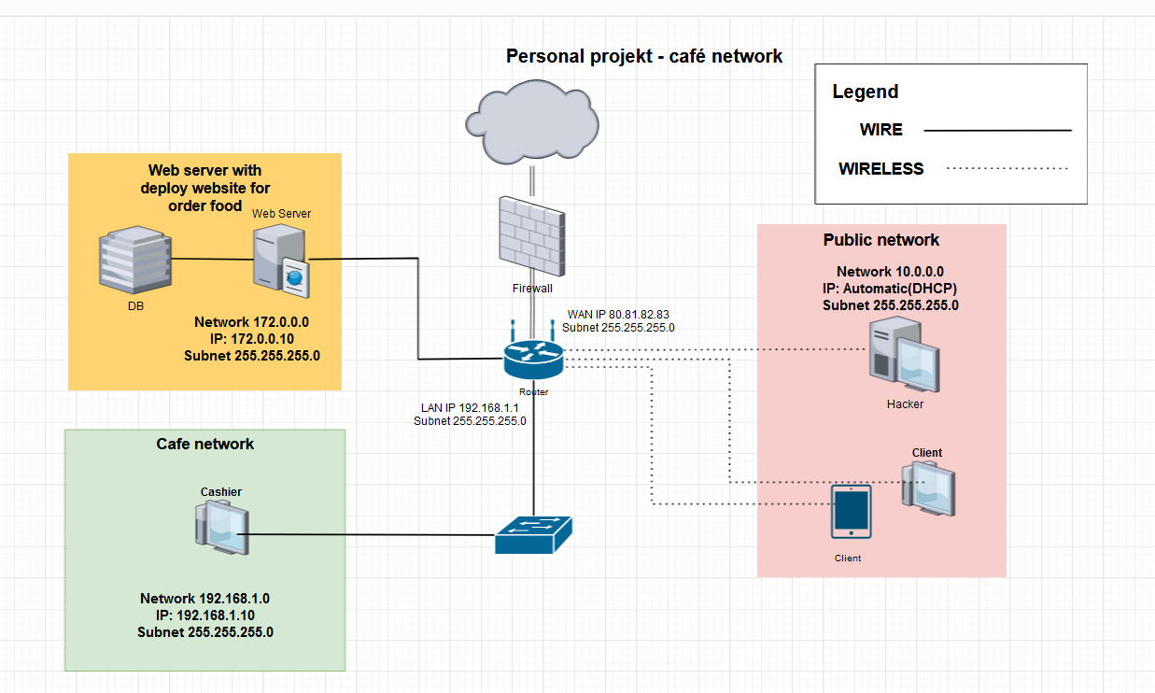

I planned to create 3 separate subnets. Yellow for webserver with database, green for cashier and pink for customers with Wi-Fi and DHCP. Customers shouldn’t be able to reach anything else than website or internet.

Then I start preparing design of my website. First I scratch it in paint and then I start creating it using css and html build on flask server.

I decide to use SQLlite3 for my database because it is serverless and lightweight. Also, SQLite supports ACID (Atomicity, Consistency, Isolation, Durability) transactions. What make it a perfect choice for small café. I prepare few database tables for my project. User table with hashed passwords, orders, join table for orderItem situation:

When I done with my website, I start prepare network in VMware where I build up all needed virtual machines and create virtual network. I assigned correct Ip addresses in cashier, server subnets and configure DHCP in customers.

Server:

Cashier:

Pfsense:

Than I configure firewall rules and install suricata to configure IDS.



When I configured network, I go to deploy my website. I decide to use CI/CD deployment available on git lab, because whenever I make changes to my code, I don’t need to reconfigure my server and redeploy it. It automatically taking the newest release in main branch.

Last step was to test my configuration here I decide to use kali Linux installed and configured in my customers subnet. Because it has pre-installed useful tools like hydra, nmap or sqlmap.

Using hydra to perform brute-force attacks in order to guess the right username and password combination. Prevent it by restrict in code for example only 5 tries from one Ip per minute.





Perform SQL injection by using sqlmap. Prevent by using variables in code.

Testing IDS rules by perform port scan by nmap.



# Challenges and learnings

## What I learned:

* I used knowledge from CP lessons to configure network, firewall and its rules, I am also preparing research document about that.
* I used knowledge from MS lesson to prepare suricata IDS/IPS on my pfsense, I am also used lessons about security to choose the best option to test my system.
* I used knowledge from programming lessons to create database (including join tables like orderItem), I use debugging skills learn during the lessons.
* Regularly working on that project help me improve mine personal skills like: focus during work, asking for feedback and time management.

## Challenges faced:

* Integrating CI/CD pipelines wasn’t hard itself but menage it to not turn off every time I stop my server on VMware take my time.
* I was using first time SQLlite3 so it was difficult but I find good examples on internet forums.
* Configure firewall to block not needed traffic to Server but letting for receiving internet and HTTP requests was complicated, because every new rule must be well thought out.

## How I overcome challenges:

* Mainly when I doing new things I am doing it with guides from YouTube
* First when I see a problem I am trying to find solution on internet forums
* If I can’t find solution or want to ask what is better for my project I am asking about feedback

# Conclusion

Thanks to this project, I was able to consolidate the knowledge I gained during the classes. I managed to achieve the goals I set for myself during the first presentation, which was to prepare a small network for the company and test it using easily accessible tools. Also, while working on the project, I faced problems such as time management or blocking progress by focusing on unnecessary features. I managed to overcome this by setting myself clear goals every week. I think the project is a success.